Derived Attribute

🌟 Definition
# Source: AI Source: Provided by: [Data Path: Persons Table -> ID Column: 1, Name_En Column: Motasem Essam] -> From: [ChatGPT] on [6/10/2026]
A Derived Attribute is an attribute whose value is calculated or obtained from other attributes, rather than being stored directly in the database.
Its value can be derived whenever needed.

🎯 Purpose
# Source: AI Source: Provided by: [Data Path: Persons Table -> ID Column: 1, Name_En Column: Motasem Essam] -> From: [ChatGPT] on [6/10/2026]
Derived attributes are used to:
- Avoid storing redundant data
- Calculate values automatically
- Keep data consistent
- Reduce storage requirements

🧠 Simple Example
# Source: AI Source: Provided by: [Data Path: Persons Table -> ID Column: 1, Name_En Column: Motasem Essam] -> From: [ChatGPT] on [6/10/2026]
Entity
Person
Attributes
DateOfBirth
Age
If a person's Date of Birth is:
15-06-2000
The Age can be calculated from the current date.
Therefore:
Age
is a Derived Attribute.

📚 Real-World Examples

1. Age
# Source: AI Source: Provided by: [Data Path: Persons Table -> ID Column: 1, Name_En Column: Motasem Essam] -> From: [ChatGPT] on [6/10/2026]
DateOfBirth → Age
Example:
DateOfBirth = 15-06-2000
Calculated:
Age = 26

2. Order Total
# Source: AI Source: Provided by: [Data Path: Persons Table -> ID Column: 1, Name_En Column: Motasem Essam] -> From: [ChatGPT] on [6/10/2026]
Quantity × UnitPrice → TotalAmount
Example:
Quantity = 5
Unit Price = $20
Calculated:
Total Amount = $100

3. Employee Experience
# Source: AI Source: Provided by: [Data Path: Persons Table -> ID Column: 1, Name_En Column: Motasem Essam] -> From: [ChatGPT] on [6/10/2026]
HireDate → YearsOfExperience
Example:
HireDate = 01-01-2020
Calculated:
Experience = 6 Years

4. Student GPA
# Source: AI Source: Provided by: [Data Path: Persons Table -> ID Column: 1, Name_En Column: Motasem Essam] -> From: [ChatGPT] on [6/10/2026]
Course Grades → GPA
GPA is calculated from course grades.

🔢 Characteristics of a Derived Attribute
# Source: AI Source: Provided by: [Data Path: Persons Table -> ID Column: 1, Name_En Column: Motasem Essam] -> From: [ChatGPT] on [6/10/2026]
A derived attribute:
- Is calculated from other attributes
- May not be physically stored
- Changes when source data changes
- Reduces duplicate data

📊 ER Diagram Representation
# Source: AI Source: Provided by: [Data Path: Persons Table -> ID Column: 1, Name_En Column: Motasem Essam] -> From: [ChatGPT] on [6/10/2026]
In ER diagrams, a derived attribute is usually shown using a dashed oval.
Example:
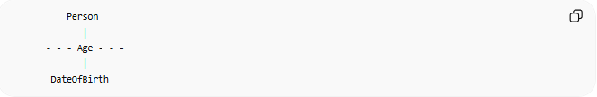
Person
│
- - - Age - - -
│
DateOfBirth
The dashed oval indicates that Age is derived.

🗄️ Database Example
# Source: AI Source: Provided by: [Data Path: Persons Table -> ID Column: 1, Name_En Column: Motasem Essam] -> From: [ChatGPT] on [6/10/2026]
Stored Data
CustomerID | DateOfBirth
1 | 2000-06-15

Derived Data
CustomerID | Age
1 | 26
Age can be calculated from DateOfBirth, so storing Age may not be necessary.

🌍 Order Example
# Source: AI Source: Provided by: [Data Path: Persons Table -> ID Column: 1, Name_En Column: Motasem Essam] -> From: [ChatGPT] on [6/10/2026]
Entity
Order
Attributes
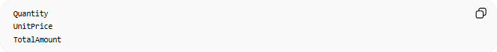
Quantity
UnitPrice
TotalAmount
Calculation:
TotalAmount = Quantity × UnitPrice
Example:
Quantity | UnitPrice | TotalAmount
3 | 100 | 300
Here, TotalAmount is a Derived Attribute.

⚠️ Derived Attribute vs Stored Attribute
# Source: AI Source: Provided by: [Data Path: Persons Table -> ID Column: 1, Name_En Column: Motasem Essam] -> From: [ChatGPT] on [6/10/2026]
Stored Attribute
DateOfBirth
Stored directly in the database.

Derived Attribute
Age
Calculated from DateOfBirth.

Comparison
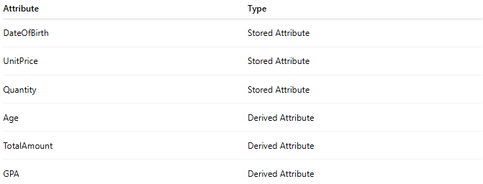
Attribute | Type
DateOfBirth | Stored Attribute
UnitPrice | Stored Attribute
Quantity | Stored Attribute
Age | Derived Attribute
TotalAmount | Derived Attribute
GPA | Derived Attribute

⚠️ Derived Attribute vs Simple Attribute
# Source: AI Source: Provided by: [Data Path: Persons Table -> ID Column: 1, Name_En Column: Motasem Essam] -> From: [ChatGPT] on [6/10/2026]
Simple Attribute
Salary
Stored directly.

Derived Attribute
MonthlyBonus
Calculated from Salary.

📚 More Examples
# Source: AI Source: Provided by: [Data Path: Persons Table -> ID Column: 1, Name_En Column: Motasem Essam] -> From: [ChatGPT] on [6/10/2026]
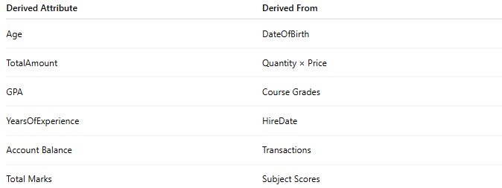
Derived Attribute | Derived From
Age | DateOfBirth
TotalAmount | Quantity × Price
GPA | Course Grades
YearsOfExperience | HireDate
Account Balance | Transactions
Total Marks | Subject Scores

🧠 Simple Analogy
# Source: AI Source: Provided by: [Data Path: Persons Table -> ID Column: 1, Name_En Column: Motasem Essam] -> From: [ChatGPT] on [6/10/2026]
Think of a shopping receipt:
Price = $20
Quantity = 5
You don't need to write the total manually.
You can calculate:
Total = $100
The Total is a Derived Attribute because it comes from other values.

🧭 Summary
# Source: AI Source: Provided by: [Data Path: Persons Table -> ID Column: 1, Name_En Column: Motasem Essam] -> From: [ChatGPT] on [6/10/2026]
A Derived Attribute is an attribute whose value is calculated from one or more other attributes rather than being stored directly. Examples include Age, Total Amount, GPA, and Years of Experience. Derived attributes help reduce redundancy and keep data consistent.

